Khuong Dinh Secondary School
THE FINAL TEST FOR ENGLISH 6
Matrận

Sections & Skills |  |  |  |  | Application |  |  |  | T.M
 | Knowledge |  | Compre |  | low |  | high
 | MCQ | E.Q | MCQ | E.Q | MCQ | E.Q | MCQ | E.Q
I. Listening | 4  2,0 |  |  |  |  |  |  |  | 4  2,0
II.Grammar and vocabulary | 5  0,5 |  | 10  2.5 |  |  |  |  |  | 10  3,0
III.Reading |  |  |  | 8  2.0 |  |  |  |  | 8  2,0
IV.Writing |  |  |  |  |  | 4  2.0 |  | 4  1.0 | 8  3,0
Total level | 9 |  | 10 | 8 |  | 4 |  | 4 | 35
Total points | 2.5 |  | 2.5 | 2,0 |  | 2.0 |  | 1.0 | 10
Total percent | 25% |  | 25% | 20% |  | 20% |  | 10% | 100%

ALISTENING
Part I. Listen to the tape and fill in the blank ( 1points)
Section 1: What name does each person use? Circle the correct answers.
1. a. Damien  b. David | 3. a. Rob  b. Bob | 5. a. Smith  b. Schmidt
2. a. Jackson  b. Johnson | 4. a. Michelle  b. Marcia | 6. a. James  b. John
Part2
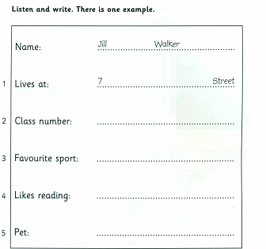
B. LANGUAGE
I. Choose the word that has the underlined part pronounced differently from the others in each group. (1.0 pt)
1. A. breathe B. fourth C. tooth D. warmth
2. A.ask B. plastic C.back D.grandparent
3. A.start B.marbles C.stars D.solar
4 . A.polluted B.prepared C. recycled D.watered

II. Choose the best answer. (2,0 pts)
- You can watch Harry Potter on TV ________ you can read it. ( so/ and/ but/ or)
- “- ________ a nice T-shirt, Trang!” _ “ Thank you” ( How / What / Which / It)
- “- ________ films have you seen this week ?” _ “ Only one”( How many/ What / Which/ Who)
- There aren’t ________ good films on TV at the moment.( some /any/ much/ a lot)
- If we cut down more trees, there - ________ more floods. (are/ were/ have been/ will be)
- That is - ________ book I’ve ever read.( the borest/ the boring /the most boring /the most bored)
- I’ ve never seen a- ________ bridge than this one.(longest/longer/most longest/ more longer)
- That dog isn’t _______it looks(most dangerous than/so dangerous as/ dangerous than/ dangerouser than)

C. READING

I . Put a word in each gap in the following postcard.
June 21st
Hi Nick,
Hue is a great city. The (1)………………..is fine. It’s has been sunny all the time. The food is cheap and (2)………………….. . The (3) …………….here are friendly and hospitable. The hotel where we’re staying is small (4)………………comfortable. Yesterday we visited the historic monuments. Tomorrow we’re (5)………………. On a trip along the Huong River.
You must visit this city someday. You’ll love it.
Bye for now!
Cheers,
Lan
II. Read the passage. Then choose the best word to fill in the blank
Lan is excited about the (1) ___ activities she is going to do. The Y&Y is (2) _____ a plan to help the community. She will (3) _______ its recycling programs. In this program, she will collect glass, used paper and empty cans. Then she will send them for (4) _______.
She hopes she can save (5)__________ resources and earn some money for her school Y&Y in these activities. She also thinks about (6) ____________ in either planting trees and flowers or helping the street children. It is really interesting, isn’t it?
1. A. interested B. interest C. interesting D. interests
2. A. having B. have C. to have D. has
3. A. take part in B. took part in C. get in D. got in
4. A. recycle B. recycling C. to recycle D. recycled
5. A. nature B. natures C. naturing D. natural
6. A. participate B. to participate C. participated D. participating
III: Read the text and answer the questions
Nowadays, football becomes one of the world’s most popular games. Millions of people play and watch it all around the world. A football match often has two parts. Each part is forty-five minutes. The first part is the first half and the second part is the second half. There is a fifteen – minute break between the two halves.
There are two teams in a football match. Each football team has eleven players, including a goal-keeper. The players on the ground try to kick the ball into the other’s goal . The team which scores more goals wins the match.
*Answer the questions
1. Does football become popular all over the world?
…………………………………………………………………………………
2. How many people often watch and play it?
…………………………………………………………………………………
3. How long does the break last between the two halves?
…………………………………………………………………………………
4. Which team is the winner of the match?
…………………………………………………………………………………

B: WRITING

- Look at the pictures and complete the sentences.
1. In the future, we will live in a .......................... 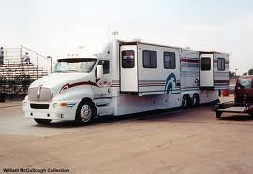
2. Robots might …………………………… 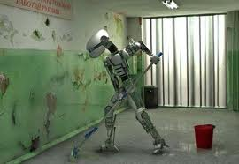
3. We should use a ……….instead of a plastic bag. 
4. Each family needs have a …… to wash clothes 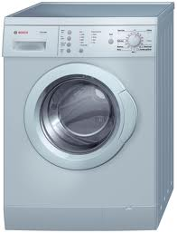
5. They are ……………… on television. 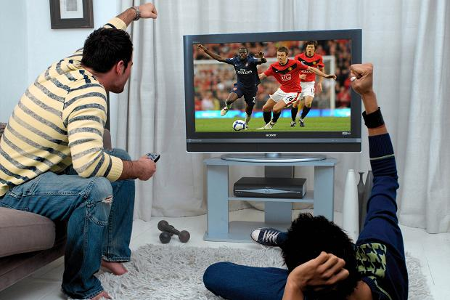

II. Complete the sentences using the given words.
- Ha Noi / the / big / city / Viet nam.
……………………………………………………………………………………
- My mother / never / visit / Ha Long Bay / before.
……………………………………………………………………………………
- If / it / sunny / next week , / we / have / picnic / mountains.
……………………………………………………………………………………
- We / can / not / speak / English / when / five / years / old.
……………………………………………………………………………………
- Please / turn / the light / when / not / use / .
……………………………………………………………………………………

III . Rewrite the following sentences.
1.I am tired. I can’t go to school today. ( because).
………………………………………………………………………………………
2. She is the most intelligent student in the class.
No student…………………………………………………………………………..
3. Nam likes cartoons most.
Nam’s favourite ……………………………………………………………………
4. Robots can wash clothes for us in the future.
Robots will be…………………………………………………………………………
5.My friend can play table tennis very well.
My friend is a……………………………………………………………………….

ĐÁP ÁN ĐỀ THI CUỐI HỌC KÌ 2 ANH 6
A .LISTENING
B. LANGUAGE
I. Choose the word that has the underlined part pronounced differently from the others in each group. (1,25pts)
1. A. breathe
2. A. ask
3. D. solar
4 . A. polluted

Part C: Reading.
I . Put a word in each gap in the following postcard. ( 0.5 )
June 21st
Hi Nick,
Hue is a great city. The (1)………weather………..is fine. It’s has been sunny all the time. The food is cheap and (2)………delicious………….. . The (3) ………people…….here are friendly and hospitable. The hotel where we’re staying is small (4)………but………comfortable. Yesterday we visited the historic monuments. Tomorrow we’re (5)………going………. on a trip along the Huong River.
You must visit this city someday. You’ll love it.
Bye for now!
Cheers,
Lan
II. Read the passage. Then choose the best word to fill in the blank ( 1.2 )
Lan is excited about the (1) ___ activities she is going to do. The Y&Y is (2) _____ a plan to help the community. She will (3) _______ its recycling programs. In this program, she will collect glass, used paper and empty cans. Then she will send them for (4) _______.
She hopes she can save (5)__________ resources and earn some money for her school Y&Y in these activities. She also thinks about (6) ____________ in either planting trees and flowers or helping the street children. It is really interesting, isn’t it?
1. A. interested B. interest C. interesting D. interests
2. A. having B. have C. to have D. has
3. A. take part in B. took part in C. get in D. got in
4. A. recycle B. recycling C. to recycle D. recycled
5. A. nature B. natures C. naturing D. natural
6. A. participate B. to participate C. participated D. participating
III: Read the text and answer the questions ( 0.8 )
Nowadays, football becomes one of the world’s most popular games. Millions of people play and watch it all around the world. A football match often has two parts. Each part is forty-five minutes. The first part is the first half and the second part is the second half. There is a fifteen – minute break between the two halves.
There are two teams in a football match. Each football team has eleven players, including a goal-keeper. The players on the ground try to kick the ball into the other’s goal . The team which scores more goals wins the match.
*Answer the questions
1. Does football become popular all over the world?
Yes, it does.
2. How many people often watch and play it?
Millions of people often watch and play it
3. How long does the break last between the two halves?
The break lasts fifteen minutes between the two halves.
4. Which team is the winner of the match?
The team which scores more goals wins the match.
Part B: Writing.

- Look at the pictures and complete the sentences. ( 0.5 )
1. In the future, we will live in a motorhome
2. Robots might clean the house
3. We should use a reusable bag instead of a plastic bag.
4. Each family needs have a washing machine to wash clothes
5. They are waching football on television
II. Complete the sentences using the given words. ( 1.0)
- Ha Noi / the / big / city / Viet nam.
Ha Noi is the biggest city in Viet Nam.
- My mother / visit / Ha Long Bay / before.
My mother has never visired Ha Long Bay before.
- If / it / sunny / next week , / we / have / picnic / mountains.
If it is sunny next week, we will have a picnic in the mountain.
- We / can / not / speak / English / when / five / years / old.
We could not speak English when we was five years old.
- Please / turn / the light / when / not / use / .
Please turn off the light when you don’t use it.

III . Rewrite the following sentences. ( 1.0 )
1.I am tired. I can’t go to school today. ( because)
Because I am tired, I can’t go to school to day.
2. She is the most intelligent student in the class.
No student in the class is more intelligent than her / she is
3. Nam likes cartoons most.
Nam’s favourite programme is cartoons.
4. Robots can wash clothes for us in the future.
Robots will be able to wash clothes for us in the future.
5.My friend can play table tennis well.
My friend is a good table tennis player.

